Product Description:
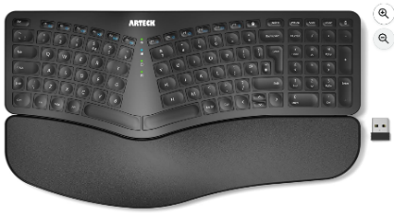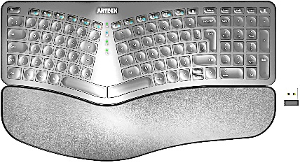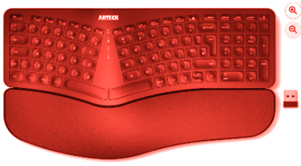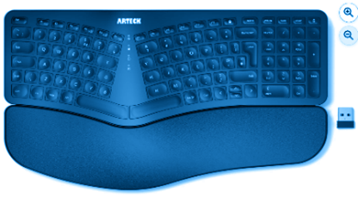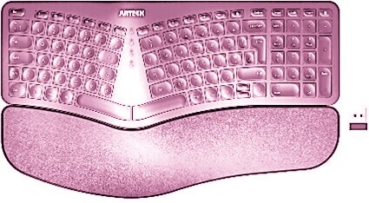
Mini Ergonomic Keyboard https://amzn.eu/d/206ZP5z
Designed for young learners, the Mini Ergonomic Keyboard supports healthy hand-muscle development and encourages confident early typing. Its compact size fits smaller hands comfortably, while the layout reduces strain on little wrists and finger joints.
Soft touch, quiet keys help maintain focus without overstimulating sensitive users. The wireless design removes risk of tangled cords and allows children to sit further from the screen, supporting safer, healthier viewing habits.
Key Features:
- Child-sized layout for comfortable typing
- Ergonomic shape to reduce joint strain
- Soft-touch keys for distraction-free using
- Wireless connection for safety and flexibility
Available in Black, Silver, Red, Blue, Pink.
Ages 7+

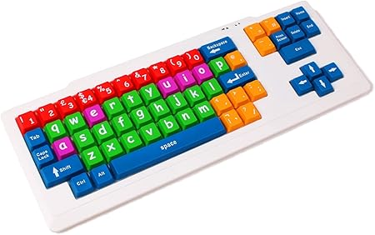
Colourful Learning Keyboard https://amzn.eu/d/ckDiKmu
A fun, educational keyboard created to support early learners. Colour-coded keys make it easier for children to recognise letters, functions, and number groups. Larger letters are imprinted on the keys to support those with sight impairment as well as reduce strain on children’s vision.
This keyboard includes fewer keys to keep learning and using simple. Wired USB design allows young users to connect independently to desired technology with ease.
Key Features:
- Colour-coded keys for easy navigation and learning
- Large print for improved visibility
- Child-friendly size with simplified layout
- Wired USB connection for reliable setup
Ages 3+

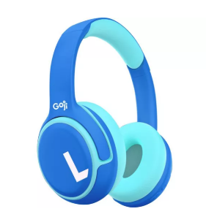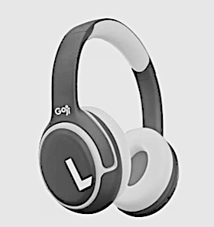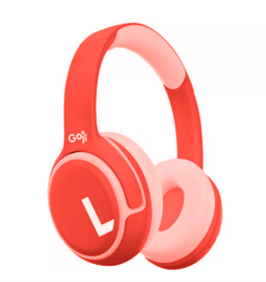
Volume-Limited Headphones https://www.currys.co.uk/products/goji-gkidbtb25-wireless-bluetooth-kids-headphones-blue-10276914.html
Comfortable, safe, and perfect for gaming and videos. These over-ear headphones feature volume-limiting technology to protect delicate eardrums, keeping audio within safe listening levels.
The wireless design removes risk of tangled cords and allows children to sit further from the screen, supporting safer, healthier viewing habits. Padded ear cushions and soft headband ensure comfortability over a longer period of time, lightweight to keep from hurting their heads, and a range of colours for all children to find their favourite.
Key Features:
- Volume-limited for safe listening
- Over-ear and cushioned for comfort
- Wireless connection for safety and flexibility
Available in Blue, Pink, White.
Ages 5+

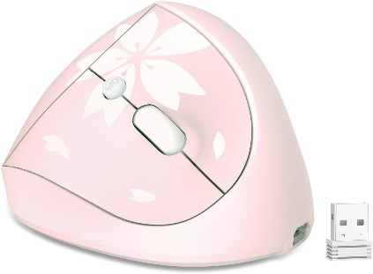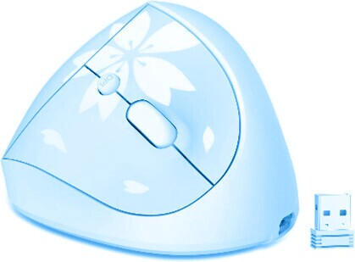

Vertical Ergonomic Mouse https://a.co/d/iLu0cSe
This vertical ergonomic mouse is designed to mimic the hand’s natural posture, reducing long-term strain on muscles and joints. Its intuitive shape helps children maintain a comfortable grip while supporting correct motor development.
The wireless design removes risk of tangled cords and allows children to sit further from the screen, supporting safer, healthier viewing habits. Available in a smaller size.
Key features:
- Vertical design supports hand position
- Reduces strain on joints
- Wireless connection for safety and flexibility
- Available in standard and smaller sizes
Available in Pink, Blue.
Ages 5+

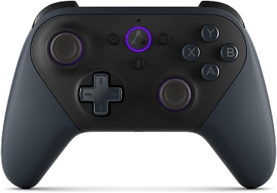
Child Controller https://amzn.eu/d/95AYZCq
The perfect controller for young gamers, designed specifically for smaller hands without compromising functionality. Compatible with all major consoles, this lightweight device encourages confident grip and comfortable gameplay.
The wireless design removes risk of tangled cords and allows children to sit further from the screen, supporting safer, healthier viewing habits.
Key Features:
- Ergonomic size for young hands
- Compatible with multiple gaming consoles
- Wireless for safety and ease of use
- Lightweight and easy to hold
Ages 3+

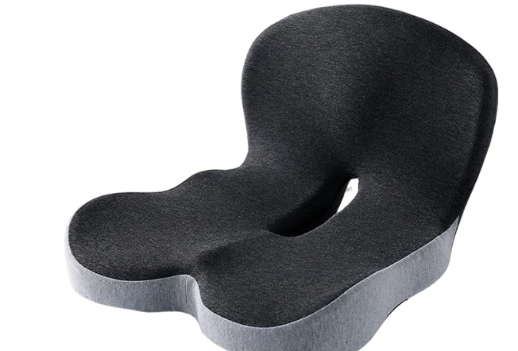
Chair Booster Seat https://a.co/d/iLu0cSe
This supportive booster seat helps children sit comfortably and supported in standard-size chairs. Designed to elevate younger users to the ideal screen or desk height, it helps maintain better posture by supporting the lower back and hips, and reduces strain to neck and eyes as level with screens.
Key Features:
- Raises children sight level with screen height
- Supports lower back and hip alignment
- Improves posture and reduces neck strain
- Works with most chair types
Ages 3+

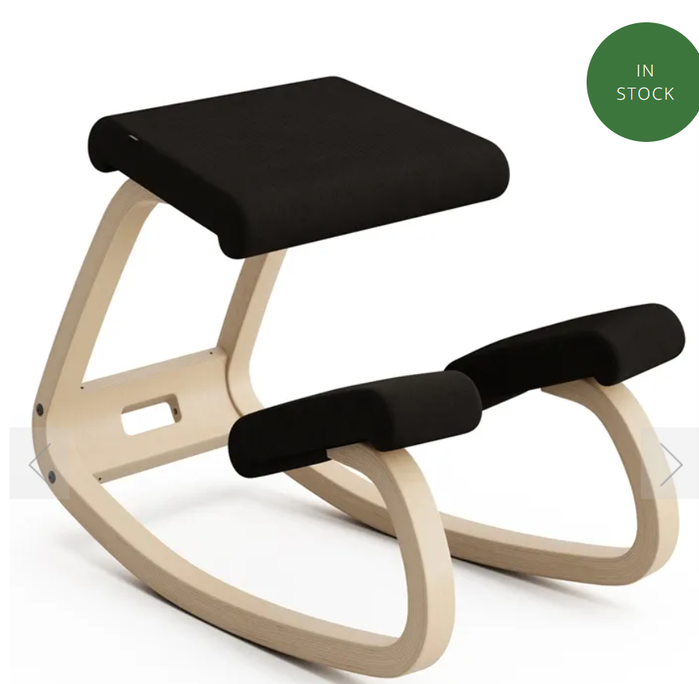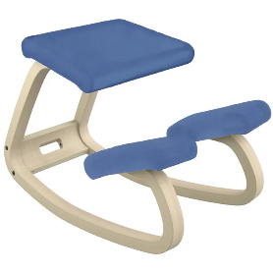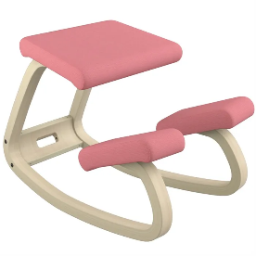
Ergonomic Movement Chair https://www.backinaction.co.uk/variable-children
Inspired by research showing that children should be mobile and upright seating is outdated, this ergonomic chair encourages natural, healthy motion while maintaining proper posture. Its design supports motor-skill development, strengthens core muscles, and prevents slouching.
Cushioned for comfort and stable to ensure safe usage.
Key Features:
- Promotes active sitting and natural movement
- Supports posture and improves core strength
- Encourages motor-skill development
- Suitable for children up to 158cm height.
Available in Black, Pink, Blue.
Ages 7+

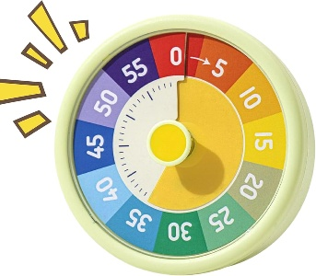
Daily Activity Timer https://amzn.eu/d/4gB2tD5
Bright, engaging colours make this 60-minute timer fun and appealing for young children. It’s an excellent tool for developing healthy habits around screen time, homework, chores, and other daily routines. Simple and visual, it helps children understand time passing and encourages gentle self-discipline.
Key Features:
- 60-minute countdown for structured routines
- Child-friendly colours for increased engagement
- Helps build healthy screen-time habits
- Useful for homework, tasks, and time-management
Ages 3+

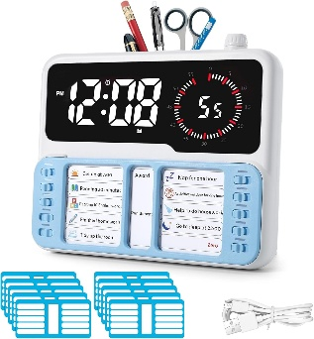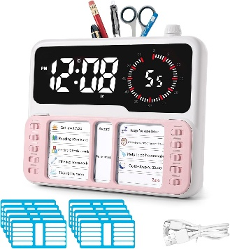
Chart and Timer Set https://amzn.eu/d/cFFvDON
This interactive chart and timer set helps children gain independence and awareness of their daily technology use. The visual timer shows how long they’ve spent on screens, while the task chart encourages organisation, responsibility, and a rewarding sense of completion. A great tool for families building balanced routines.
Key Features:
- Visual clock and timer to track screen time
- Interactive task chart for motivation and organisation
- Encourages independence and responsibility
- Supports healthy technology habits
Available in Blue, Pink.
Ages 5+
About Us Page:
Welcome to PixelPals, where play, comfort, and healthy habits come together!
We believe that gaming should be fun, safe, and supportive for every child. We understand that technology, gaming, and media is the new form of connection and community. But prolonged exposure can cause concerns to their wellbeing.
That’s why we create accessories designed especially for young gamers ages 3 to 12, helping them enjoy their favourite activities while protecting their eyes, ears, and growing bodies.
At PixelPals, we worked in accordance with specialist studies to design products that are comfortable, durable and made for small hands and big imaginations. From sound-sensitive headphones and easy-grip mouses, to colourful keyboards and posture friendly chairs, we are here to help every younger player game as healthily as possible.
Our products don’t just support kids. We have found they can be compatible with elder users, neurodivergent users, and people with physical disabilities, thanks to their soft-touch materials, ergonomic designs, and accessible features.
As a brand, we want to:
- Encourage healthier screen habits
- Protect hearing and vision
- Support motor development
- Reduce stress and strain
Home Page:
Welcome to PixelPals, where play, comfort, and healthy habits come together!
We support healthy gaming habits by ensuring children have safe equipment whilst playing.
Find out more about each product!

